Software Development Methodologies
- You will learn several commonly used approaches to the software development life cycle
- Explain Waterfall, V-shape model, and agile methods.
- Compare pros and cons of each method

Common Development Methodologies
A process is needed to clarify communication and facilitate information sharing among team members. Determine when information is shared and where.

Waterfall
V-shape
Agile method

Waterfall method
Plan>Design>Develop>Test>Deploy>Maintain
Customer does not see product until testing phase

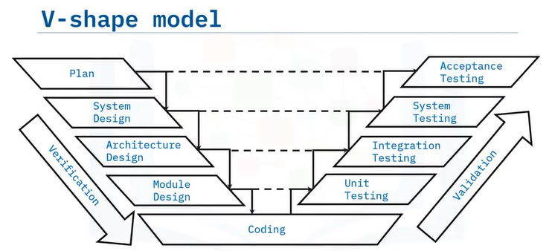

Agile Method:
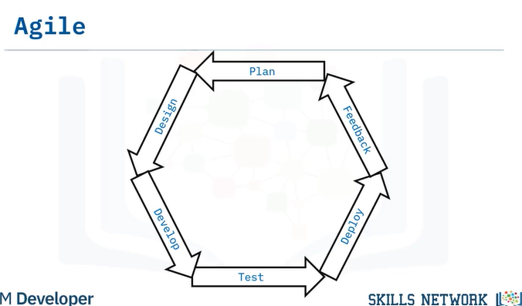
MVP is released after several cycles.

Waterfall and V-shape model: Sequential
Meaning we move in a straight line, we follow patterns.

Agile: Iterative
Meaning we focus on short bursts of development.

Waterfall pros:
Team members understand their responsibilities due to discrete, well-defined stages.
Easier to estimate the budget and allocate resources

Cons:
Lack flexibility
Change is hard to accommodate because it can cause huge complications later on.

V-Shape Pros:
Easy to use
Test plans designed up front save development and testing time

Cons:
Rigid more than waterfall method.
Does not accommodate changing requirements.
Agil pros:
Changing requirements is handled easily
Feedback incorporated regularly

Cons
Budgeting and resource allocation are challenging
The project score is not clearly defined.

Software Versions
You will learn:
Discuss software versions
Identify software versions and numbering

Software versions are identified by version numbers, and software users can see which version they are using.

They vary in length and share similar info.

Version numbers indicate:
When the software was released
When it was updated
If any minor changes or fixes were made to the software.

Software developers use versioning to keep track of new software updates and patches.

Version number can be displayed in different ways:
Version numbers can be short or long, with 2,3 or 4 sets
Each number set is divided by a period
An application with a 1.0 version number indicates the first release.
Software with many releases and updates will have a larger number
Some use dates for versioning such as ubuntu Linux version 18.04.2 released in 2018 April with a change shown in the third number set.

What does these numbers mean?
First number indicates big releases such as new release.
Second number indicates that minor changes were made to a piece of the software.
The third is the version number indicates patches or minor fixes
The fourth number indicates build numbers, build dates and less significant changes for example
Version 9.1.33.6
Look for setting or help and see you will see version
It can be useful when checking version if its old or newer
To checks whether it is compatible with newer or older models
Troubleshoot compatibility issues by viewing the software version.
Some software needs update to newer version with is compatible.
Backward-compatible software functions properly with older versions of files programs and systems.

Software Testing
You will learn to define the term functional, non-functional and regression testing.
Compare and contrast testing levels.

Software testing is integrating quality checks
Checks whether it meets stakeholders’ requirements
Verify the functionality and requirements.
Tests process contains:
- Steps
- Inputs
- Data
- Expected output
Test cases should always be written
Three types of testing
Functional testing
- Black box testing: without looking at the source code, it concerns of only the input and corresponding output of the system undertest SUT system under test. It can be done manually
Purpose: to make sure it is usable and accessible
For example: if user enters wrong details it the software gives a prompt using appropriate messages.
Non-functional testing attributes
- Performance
- Scalability
- Security
- Availability
Checks to see if non-functional behaviors are functioning appropriately.
How to perform non-functional testing:
It is by asking question:
- How does the application behave under stress?
- What happens when many users log in at the same time?
- Are the instructions consistent with behavior?
- How does the application behave under different OS?
- How does the application handle disaster recovery
- How secure is the application?

Regression testing
Confirms changes don’t break the application
Occurs after fixes

It can be challenging and special test cases.
Choose test cases that contain:
- Frequent defects
- Frequently used functionality
- Features with recent changes
- Complex cases
- Edge cases
- Randomly successful or failed cases.

Testing levels
There are 4 testing levels
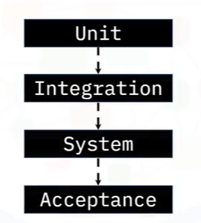
This is because to avoid over testing and overlapping
Unit testing: test a module of code, performed in development phase
Eliminate errors before integration with other modules.
Increases quality of software

Integration testing
Identify errors introduces when two or more modules are combined
Type of black box test
Occurs after modules are combined into the larger application

Occurs when unit of codes interacts with each other
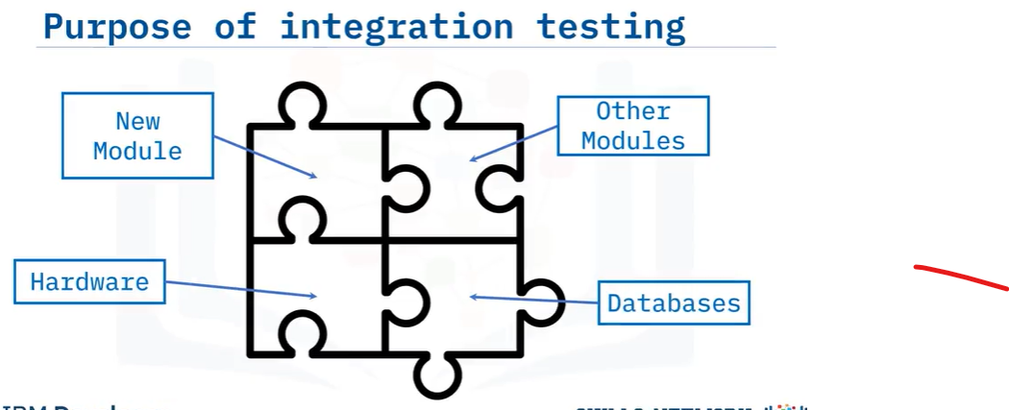

System testing is done after integration testing
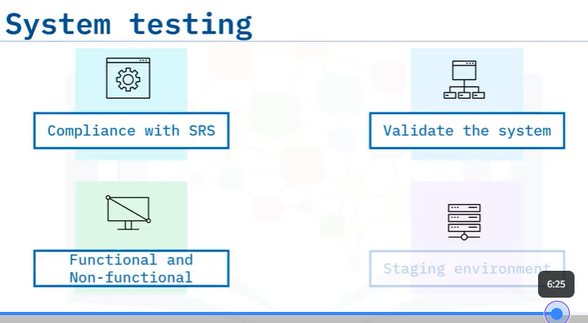

Acceptance testing
It determines if it satisfy the users.

Software documentation
you will learn:
- list documentation formats
- compare and contrast product and process documentation
- describe different types of documentation
- explain the purpose of standard operating procedures.

Software documentation:
It is information about software that describe what the product is and how to use it. This can be:
- written assets
- video assets
- graphical assets
it is done for end users, stakeholders etc…

Product vs process documentation
Product documentation relates to product functionality.
Process documentation describes how to complete a task.

Types of documentation
- requirements
- design
- technical
- QA
- User

Requirements:
Written for the development team, including developers, architects, and QA. Describes expected features and functionality.
Software requirements specifications, system requirements specifications, and user acceptance specifications.
Design documentation:
Written by architects and the development team to explain how the software will be built to meet requirements.
Consists of both conceptual and technical design documentation.
Technical documentation:
Written in the code to help developers read the code
Comments embedded in code and working papers that explain how the code works, document the record ideas and thoughts during implementation.
Quality assurance documentation:
Pertains to the testing team’s strategy, progress, and metrics
Involves test plans, test data, test scenarios, test cases, test strategies, and traceability matrices.

User documentation:
Intended for end-users to explain how to operate the software or help install and troubleshoot the system.
Involves FAQs, installation and help guides, tutorials, and user manuals.

Standard operating procedures:
- Accompanies process documentation.
- Step-by-step instructions on how to accomplish common yet complex tasks.
- Ex: organization-specific instructions for checking in code to a repository.
Types of SOPs:
- Flowcharts
- Hierarchical
- Step-by-step approaches

Updating documentation
- Must be kept up to date
- Documentation should be reviewed and updated periodically.

Roles in Software Engineering Projects
What you will learn:
- List common roles on a software engineering projects
- Describe each role
- Explain the responsibilities of each role
Roles are:
- Project manager / Scrum master
- Stakeholder
- System / software architect
- UX designer
- Developer
- Tester / QA engineer
- Site reliability / ops engineer
- Product manager / product owner
- Technical writer / information developer

Project manager / Scrum master
Project manager
- Planning, scheduling and budgeting
- Allocating personnel and resources
- Executing the software plan
- Team communication
Scrum Master
- Ensure team success
- Individual success
- Prioritize people over process
- Focused on facilitating communication between all team members
Stakeholders
Interested parties who are affected by the software product:
Customer, end-users, decision-maker
Responsibilities:
- Defines requirements
- Provides feedback on requirements
- May participate in beta and acceptance testing

System / software architect
Designs, describes, and communicates architecture of a project to team members
Responsibilities:
- Designs inner structure
- Designs technical aspects
- Provides technical support regarding the architecture

UX designer
Balances making software interface intuitive yet also robust
Responsibilities:
- How software communicates functionality to the user
- How the user interacts with the software

Developer
Writes the code that powers the software
Responsibilities:
- Implement architecture in design documents
- Incorporate SRS requirements
- Employ UX designs

Tester / QA engineer
Ensures quality of the product by testing to see if the software meets requirements
Responsibilities:
- Writes and executes test cases
- Provides feedback to development teams

Site reliability engineer
Bridges software development and operations
Responsibilities:
- Tracks and communicates incidents
- Automates systems, procedures, and processes
- Troubleshoot
- Ensure product reliability

Product manager / product owner
Understand requirements and end-user needs
Responsibilities:
- Leads development efforts
- Ensures product provides value to the customer

Technical writer / Information developer
Writes documentation for end-user
Technical material – non technical audience
Responsibilities:
- Writes user manuals
- Writes reports
- Writes white papers
- Writes press releases
m

